CNC Ultra-Sonic Tagging Machine Operation Flow Chart

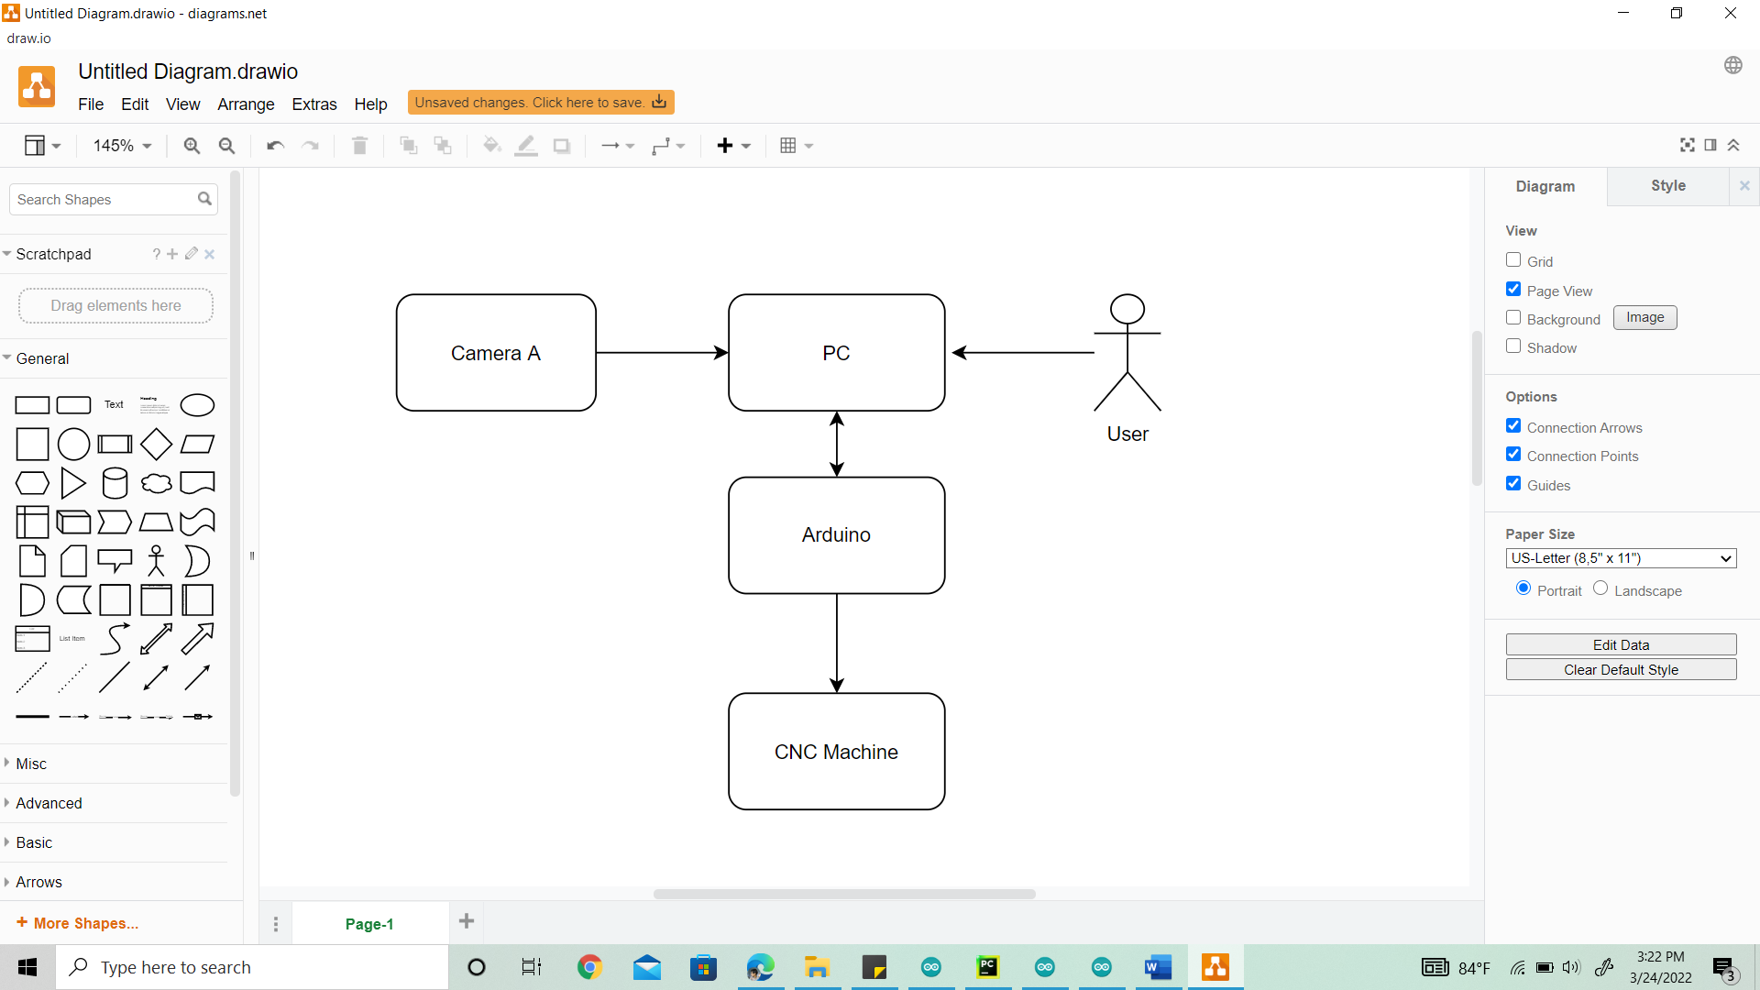Figure 01 – Flow Chart

**Blocks and their Functions**

* **Camera A –** 
  + Capture and send the Optical data.
* **PC –** 
  + Calibration.
  + Onboard Procedure.
  + Image processing and G code Generation.
* **User –** 
  + Calibrate Once in a while.
  + Onboard Incoming panels (one time operation).
  + Running the program.
    - Select panel type
    - Click on screen to take image
* **Arduino –** 
  + Back and forth communication with PC.
  + Send Pulses to Motor drives in CNC Machine.
* **CNC Machine –** 
  + Moving ultra-sonic tag gun.
  + Tag the garment using pneumatic.
* **How the Running Operation Works**

Select Panel

Run

Figure 02 – Sample of the UI

* Select Panel task is a dropdown task.
* Run in the above UI is a button.
* User can place N number of panels adhering to M number of Orientations.
* After Placing panels, User clicks the Run button and everything will be Automatically work according to the need.

**Calibration Procedure**

* Place the pre printed pattern on the bed.
* Carefully aligned to x , y movement axis.
* Follow guided Procedure on the screen.
* Entry of values clicking on the screen.

**Onboard Procedure**

* Panels can be placed in fixed number of orientations(M).
* A guided procedure with entry of values and clicking on screen to specify tagging locations.
* Orientation specific data must be captured M times.